Stagg Property Services Ltd (the ‘Organisation’) aims to provide defect free products to its customers on time and within budget.

The Organisation operates a Quality Management System that has gained BS EN ISO 9001: 2015 certification, including aspects specific to property services for the construction and building industry.

The management is committed to:

- Develop and improve the Quality Management System.
- Continually improve the effectiveness of the Quality Management System.
- The enhancement of customer satisfaction.

The management has a continuing commitment to:

- Ensure that customer needs and expectations are determined and fulfilled with the aim of achieving customer satisfaction.
- Communicate throughout the Organisation the importance of meeting customer needs and all relevant statutory and regulatory requirements.
- Establish the Quality Policy and its objectives.
- Ensure that the Management Reviews set and review the quality objectives, and reports on the Internal Audit results as a means of monitoring and measuring the processes and the effectiveness of the Quality Management System.
- Ensure the availability of resources.

The structure of the Quality Management System is defined in the Quality Manual.

All personnel understand the requirements of this Quality Policy and abide with the contents of the Quality Manual.

The Organisation complies with all relevant statutory and regulatory requirements.

The Organisation constantly monitors its quality performance and implements improvements when appropriate.

This Quality Policy is regularly reviewed in order to ensure its continuing suitability.

Copies of the Quality Policy are made available to all members of staff. Copies of the minutes of Management Reviews, or extracts thereof, are provided to individual members of staff in accordance with their role and responsibilities as a means of communicating the effectiveness of the Quality Management System.

Signed on behalf of Stagg Property Services Limited.
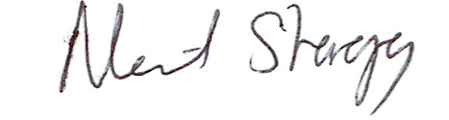

Neil Stagg
Managing Director
December 2023

